Git - Staging

From Workspace to staging
# Source: AI Source: Provided by: [Data Path: Persons Table -> ID Column: 1, Name_En Column: Motasem Essam] -> From: [ChatGPT] on [2/19/2026]
It sounds like you want to move changes from your local workspace (working directory) to the staging area in GitHub (really in Git, since GitHub is remote). Let’s break it down clearly:

Check your current workspace status
# Source: AI Source: Provided by: [Data Path: Persons Table -> ID Column: 1, Name_En Column: Motasem Essam] -> From: [ChatGPT] on [2/19/2026]
In your terminal:
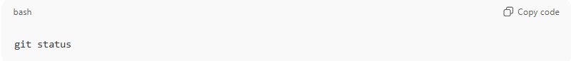
git status
This shows:
- Modified files that are not yet staged
- Untracked files
- Current branch

Stage changes
# Source: AI Source: Provided by: [Data Path: Persons Table -> ID Column: 1, Name_En Column: Motasem Essam] -> From: [ChatGPT] on [2/19/2026]
To move changes from your workspace to staging, you use:
a) Stage specific files:
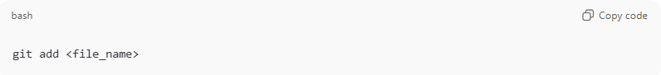
git add <file_name>
Example:
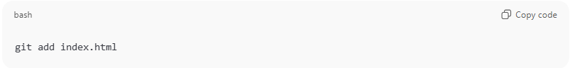
git add index.html
b) Stage all changes at once:
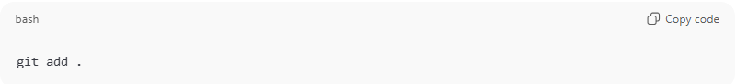
git add .
This adds all modified and new files to the staging area.

Verify staging area
# Source: AI Source: Provided by: [Data Path: Persons Table -> ID Column: 1, Name_En Column: Motasem Essam] -> From: [ChatGPT] on [2/19/2026]
After staging, you can check:
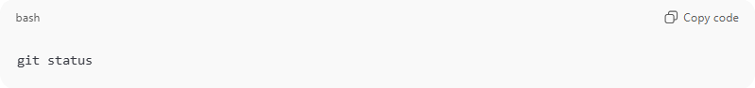
git status
You should see the files under “Changes to be committed”. That means they are now staged.

Moving files in Staging Area
# Source: AI Source: Provided by: [Data Path: Persons Table -> ID Column: 1, Name_En Column: Motasem Essam] -> From: [ChatGPT] on [2/19/2026]
Moving files (git mv)
- If you rename or move a file, Git needs to track it.
- git mv is a shortcut that does both the file move and stages it at the same time.
Example:
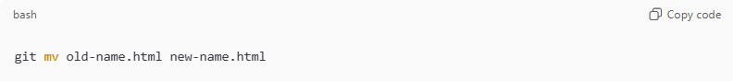
git mv old-name.html new-name.html
- This will:
  - Rename the file in your working directory.
  - Stage the change for the next commit (so Git knows the file was moved/renamed).
Equivalent manually:
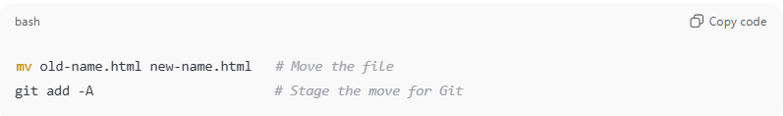
mv old-name.html new-name.html # Move the file
git add -A # Stage the move for Git

Removing files in Staging Area
# Source: AI Source: Provided by: [Data Path: Persons Table -> ID Column: 1, Name_En Column: Motasem Essam] -> From: [ChatGPT] on [2/19/2026]
Removing files (git rm)
- If you delete a file, Git doesn’t automatically know about it. You must stage the deletion.
Example:
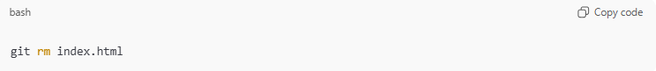
git rm index.html
- git rm deletes the file from the working directory and stages the deletion.
- If you already deleted the file manually, you can stage the deletion with:
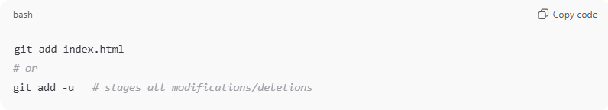
git add index.html
# or
git add -u # stages all modifications/deletions

💡 Tip:
After any move or deletion, you can always check what’s staged with:
git status
This is the easiest way to see if Git recognizes your file moves or deletions.

Example

Check your current workspace status
# Source: ScreenShots Source: Provided by: [Persons Table -> ID Column: 1, Name_En Column: Motasem Essam] -> Tool: [Lightshot Program] -> From [Operating System: Windows] on [2/19/2026]
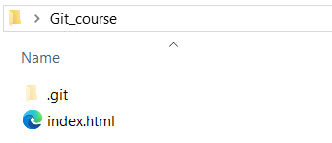
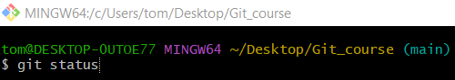
git status
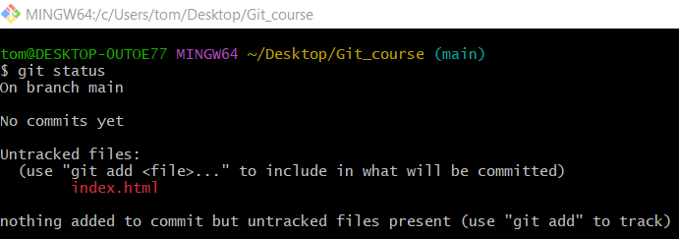

Stage changes

a) Stage specific files
# Source: ScreenShots Source: Provided by: [Persons Table -> ID Column: 1, Name_En Column: Motasem Essam] -> Tool: [Lightshot Program] -> From [Operating System: Windows] on [2/19/2026]
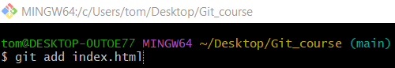
git add index.html

b) Stage all changes at once
# Source: ScreenShots Source: Provided by: [Persons Table -> ID Column: 1, Name_En Column: Motasem Essam] -> Tool: [Lightshot Program] -> From [Operating System: Windows] on [2/19/2026]
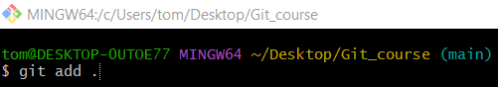
git add .

Verify staging area
# Source: ScreenShots Source: Provided by: [Persons Table -> ID Column: 1, Name_En Column: Motasem Essam] -> Tool: [Lightshot Program] -> From [Operating System: Windows] on [2/19/2026]

git status
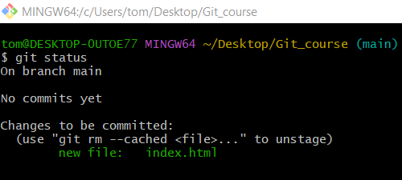

Moving files in Staging Area
# Source: ScreenShots Source: Provided by: [Persons Table -> ID Column: 1, Name_En Column: Motasem Essam] -> Tool: [Lightshot Program] -> From [Operating System: Windows] on [2/19/2026]
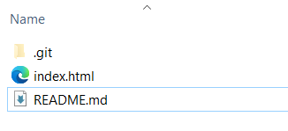
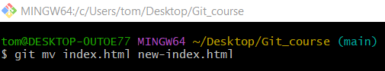
git mv index.html new-index.html
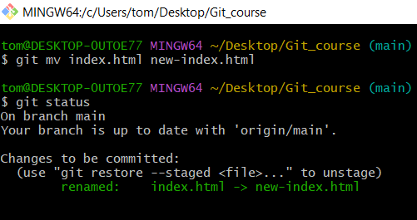

Removing files in Staging Area
# Source: ScreenShots Source: Provided by: [Persons Table -> ID Column: 1, Name_En Column: Motasem Essam] -> Tool: [Lightshot Program] -> From [Operating System: Windows] on [2/19/2026]
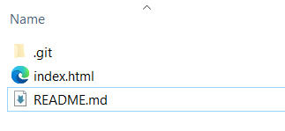
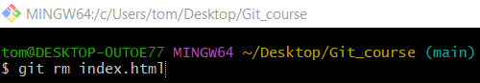
git rm index.html
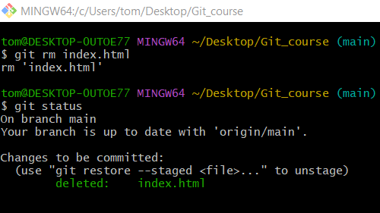

From staging to Workspace
# Source: AI Source: Provided by: [Data Path: Persons Table -> ID Column: 1, Name_En Column: Motasem Essam] -> From: [ChatGPT] on [2/19/2026]
Ah! You’re asking about going from staging back to the workspace — basically unstaging changes in Git. This is like saying, “Oops, I staged this, but I’m not ready to commit it yet.”
Here’s how to do it:

Check what’s staged
# Source: AI Source: Provided by: [Data Path: Persons Table -> ID Column: 1, Name_En Column: Motasem Essam] -> From: [ChatGPT] on [2/19/2026]
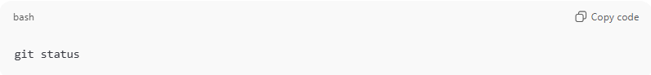
git status
You’ll see something like:
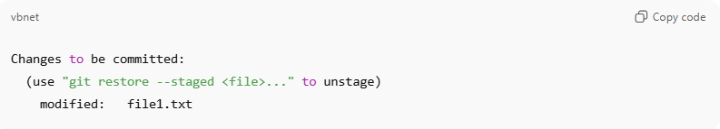
Changes to be committed:
(use "git restore --staged <file>..." to unstage)
modified: file1.txt
Files listed under “Changes to be committed” are staged.

Unstage a file (move from staging back to workspace)
# Source: AI Source: Provided by: [Data Path: Persons Table -> ID Column: 1, Name_En Column: Motasem Essam] -> From: [ChatGPT] on [2/19/2026]
a) Single file
If your repository already has at least one commit:
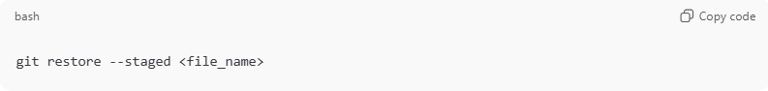
git restore --staged <file_name>
Example:
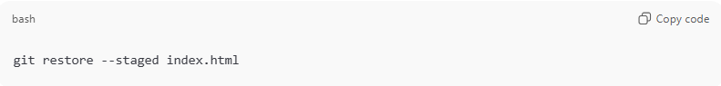
git restore --staged index.html

If your repository has no commits yet, use:
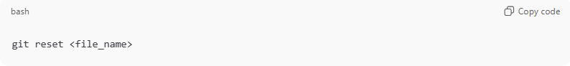
git reset <file_name>
Example:
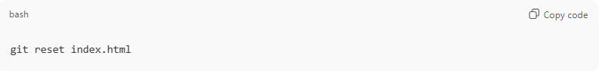
git reset index.html

b) All staged files
If your repository already has commits:
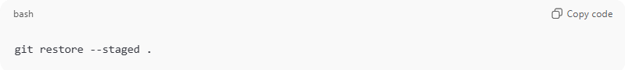
git restore --staged .
If your repository has no commits yet, use:
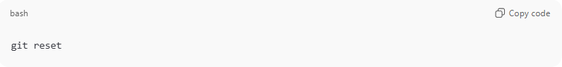
git reset
This unstages all files but keeps your changes in the working directory.

Verify
# Source: AI Source: Provided by: [Data Path: Persons Table -> ID Column: 1, Name_En Column: Motasem Essam] -> From: [ChatGPT] on [2/19/2026]
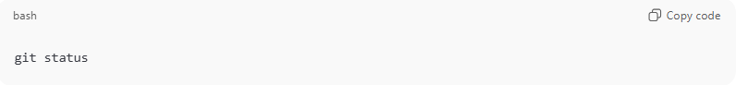
git status
Now the files should appear under “Changes not staged for commit” — meaning they’re back in your workspace but not staged.

⚡ Tip: In older Git versions, git reset HEAD <file> works the same way.

Example

Check what’s staged
# Source: ScreenShots Source: Provided by: [Persons Table -> ID Column: 1, Name_En Column: Motasem Essam] -> Tool: [Lightshot Program] -> From [Operating System: Windows] on [2/19/2026]

git status


Unstage a file (move from staging back to workspace)
# Source: ScreenShots Source: Provided by: [Persons Table -> ID Column: 1, Name_En Column: Motasem Essam] -> Tool: [Lightshot Program] -> From [Operating System: Windows] on [2/19/2026]
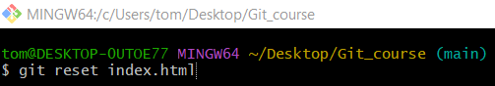
git reset index.html

Verify
# Source: ScreenShots Source: Provided by: [Persons Table -> ID Column: 1, Name_En Column: Motasem Essam] -> Tool: [Lightshot Program] -> From [Operating System: Windows] on [2/19/2026]

git status
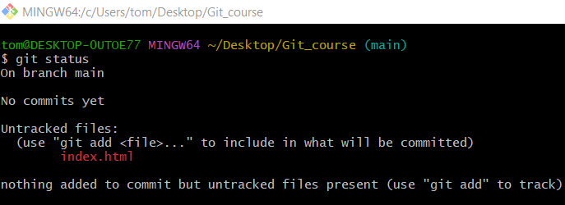

Differences between staged and unstaged changes
# Source: AI Source: Provided by: [Data Path: Persons Table -> ID Column: 1, Name_En Column: Motasem Essam] -> From: [ChatGPT] on [2/19/2026]
Let’s clarify the differences between staged and unstaged changes in Git, because this is a concept that often confuses beginners.

1️⃣ Unstaged Changes (Working Directory)
# Source: AI Source: Provided by: [Data Path: Persons Table -> ID Column: 1, Name_En Column: Motasem Essam] -> From: [ChatGPT] on [2/19/2026]
- These are the changes you’ve made to your files, but haven’t told Git you want to include them in the next commit.
- Git sees them as “in progress” but not ready to save permanently.
Command to see them:
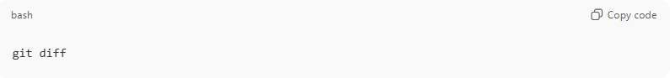
git diff
- This shows line-by-line changes in your files that are not yet staged.
- Example output snippet:
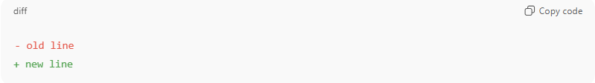
- old line
+ new line

2️⃣ Staged Changes (Staging Area / Index)
# Source: AI Source: Provided by: [Data Path: Persons Table -> ID Column: 1, Name_En Column: Motasem Essam] -> From: [ChatGPT] on [2/19/2026]
- Staged changes are the ones you’ve added with git add, meaning Git will include them in your next commit.
- You can think of staging as “preparing changes for commit.”
Command to see them:
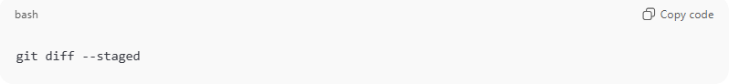
git diff --staged
or
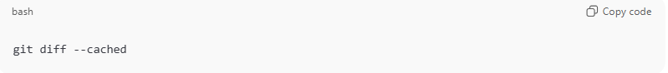
git diff --cached
- This shows the changes that are ready to be committed, compared to the last commit.

Workflow Visual
# Source: AI Source: Provided by: [Data Path: Persons Table -> ID Column: 1, Name_En Column: Motasem Essam] -> From: [ChatGPT] on [2/19/2026]
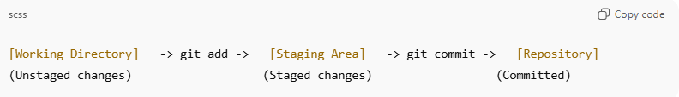
[Working Directory] -> git add -> [Staging Area] -> git commit -> [Repository]
(Unstaged changes) (Staged changes) (Committed)
- Edit files → changes are unstaged
- git add <file> → moves changes to staging area
- git commit → saves staged changes permanently in Git history

Quick Example
# Source: AI Source: Provided by: [Data Path: Persons Table -> ID Column: 1, Name_En Column: Motasem Essam] -> From: [ChatGPT] on [2/19/2026]
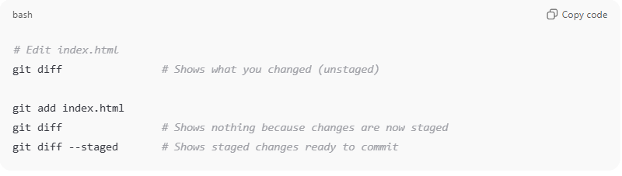
# Edit index.html
git diff # Shows what you changed (unstaged)

git add index.html
git diff # Shows nothing because changes are now staged
git diff --staged # Shows staged changes ready to commit

Optional navigation in the pager
# Source: AI Source: Provided by: [Data Path: Persons Table -> ID Column: 1, Name_En Column: Motasem Essam] -> From: [ChatGPT] on [2/19/2026]
While inside the less view, you can also:
- Space → go to the next page
- b → go back one page
- /text → search for “text”
- n → go to next search result
But usually, just pressing q is enough to exit.

💡 Key point:
# Source: AI Source: Provided by: [Data Path: Persons Table -> ID Column: 1, Name_En Column: Motasem Essam] -> From: [ChatGPT] on [2/19/2026]
- Unstaged: changes in your working files
- Staged: changes ready for commit

Example
# Source: ScreenShots Source: Provided by: [Persons Table -> ID Column: 1, Name_En Column: Motasem Essam] -> Tool: [Lightshot Program] -> From [Operating System: Windows] on [2/19/2026]

git status

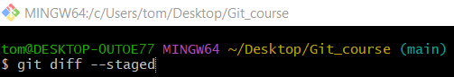
git diff --staged
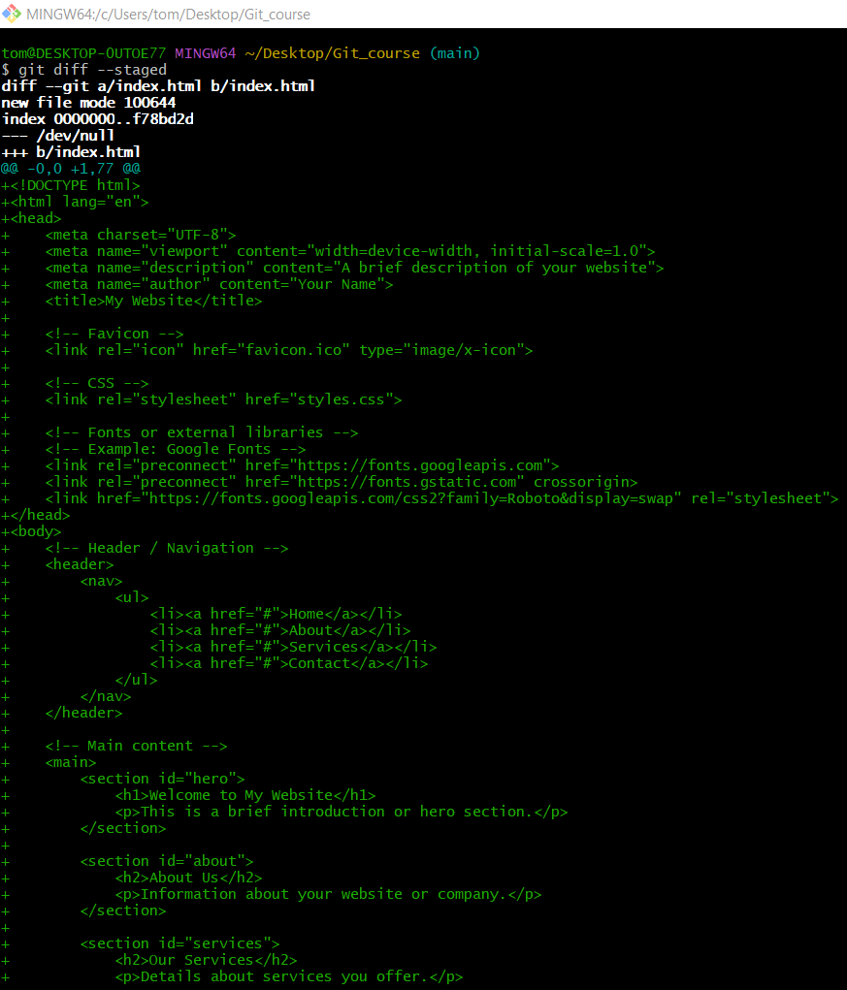

Git Stash Commands

✅ What is Stash Changes in Git?
# Source: AI Source: Provided by: [Data Path: Persons Table -> ID Column: 1, Name_En Column: Motasem Essam] -> From: [ChatGPT] on [2/19/2026]
Git stash temporarily saves your changes in your working directory and staging area so you can switch branches or work on something else without committing unfinished work.
It:
- Saves modified and staged files
- Cleans your working directory
- Stores changes in a stack (LIFO order)
Think of it as a temporary shelf for unfinished work.

📦 Most Important Git Stash Commands

✅ 1. Stash Current Changes

Method 1: git stash
# Source: AI Source: Provided by: [Data Path: Persons Table -> ID Column: 1, Name_En Column: Motasem Essam] -> From: [ChatGPT] on [2/19/2026]
🔹 Syntax
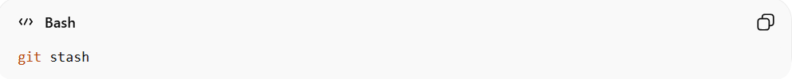
git stash
🔹 Explanation
- This is the older shorthand command.
- By default, it stashes:
  - Modified tracked files
  - Staged changes
- It is basically a shortcut for git stash push.
🔹 Example
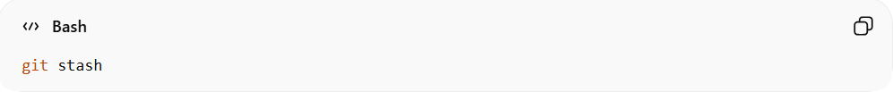
git stash
Saves your current changes and cleans your working directory.

Method 2: git stash push
# Source: AI Source: Provided by: [Data Path: Persons Table -> ID Column: 1, Name_En Column: Motasem Essam] -> From: [ChatGPT] on [2/19/2026]
🔹 Syntax
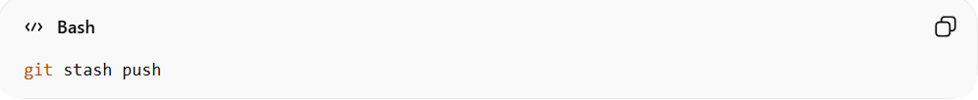
git stash push
🔹 Explanation
- This is the newer and recommended command.
- More explicit and flexible.
- Allows extra options like:
  - Adding a message (-m)
  - Including untracked files (-u)
  - Stashing specific files
🔹 Example
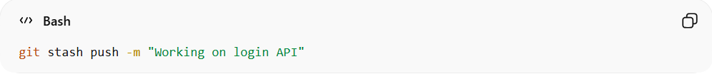
git stash push -m "Working on login API"

Method 3: Stash Specific Files
# Source: AI Source: Provided by: [Data Path: Persons Table -> ID Column: 1, Name_En Column: Motasem Essam] -> From: [ChatGPT] on [2/19/2026]
🔹 Syntax
- Single file
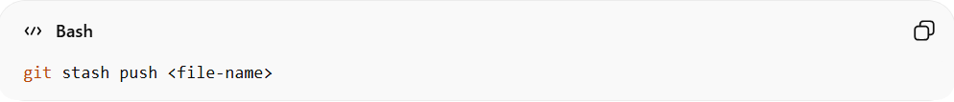
git stash push <file-name>
- Multiple files
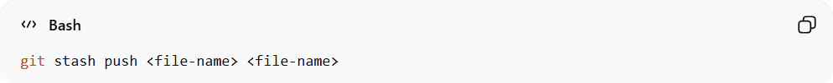
git stash push <file-name> <file-name>
🔹 Explanation
- Stashes only the specified files.
- Other modified files remain untouched.
- Useful when you want to temporarily save changes in certain files only.
🔹 Example
- Single file
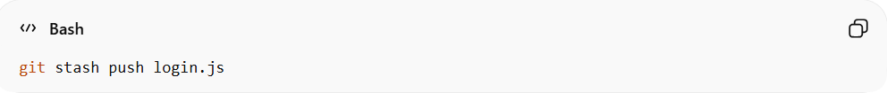
git stash push login.js
Only login.js will be stashed.
Other modified files will remain in your working directory.
- Multiple files
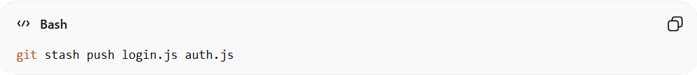
git stash push login.js auth.js
Only login.js and auth.js will be stashed.
Other modified files will remain in your working directory.

🎯 Key Difference
# Source: AI Source: Provided by: [Data Path: Persons Table -> ID Column: 1, Name_En Column: Motasem Essam] -> From: [ChatGPT] on [2/19/2026]
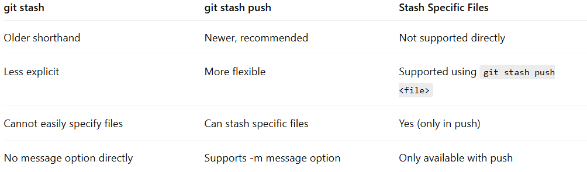
git stash | git stash push | Stash Specific Files
Older shorthand | Newer, recommended | Not supported directly
Less explicit | More flexible | Supported using git stash push <file>
Cannot easily specify files | Can stash specific files | Yes (only in push)
No message option directly | Supports -m message option | Only available with push

✅ 2. Stash Including Untracked Files

Method 1: git stash -u
# Source: AI Source: Provided by: [Data Path: Persons Table -> ID Column: 1, Name_En Column: Motasem Essam] -> From: [ChatGPT] on [2/19/2026]
🔹 Syntax
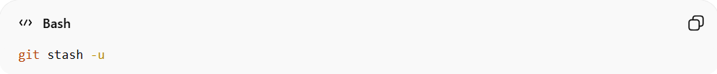
git stash -u
🔹 Explanation
- This is the short/legacy form.
- It is equivalent to:
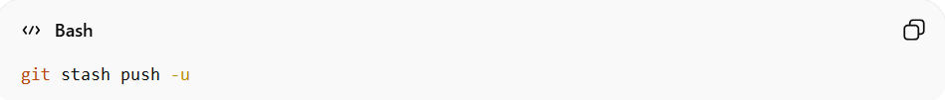
git stash push -u
- Stashes:
  - Modified tracked files
  - Staged changes
  - Untracked files
🔹 Example
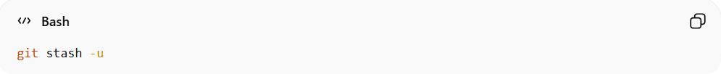
git stash -u
If you created a new file test.js (not added), it will also be stashed.

Method 2: git stash push -u
# Source: AI Source: Provided by: [Data Path: Persons Table -> ID Column: 1, Name_En Column: Motasem Essam] -> From: [ChatGPT] on [2/19/2026]
🔹 Syntax
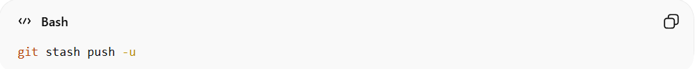
git stash push -u
🔹 Explanation
- This is the newer, recommended, and explicit form.
- More flexible.
- Allows combining options like:
  - Message
  - Specific files
  - Patch mode
🔹 Example
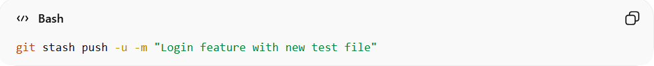
git stash push -u -m "Login feature with new test file"

Method 3: Stash Specific Files Including Untracked
# Source: AI Source: Provided by: [Data Path: Persons Table -> ID Column: 1, Name_En Column: Motasem Essam] -> From: [ChatGPT] on [2/19/2026]
- Single file
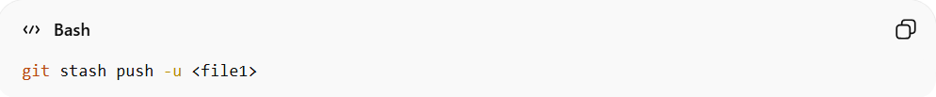
git stash push -u <file1>
- Multiple Files
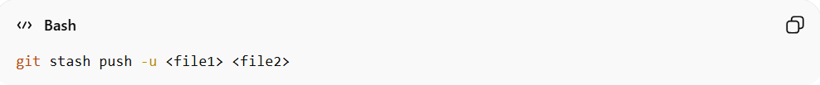
git stash push -u <file1> <file2>
🔹 Explanation
- Stashes only the specified file, even if it is untracked.
- Other modified or untracked files remain in the working directory.
🔹 Example
- Single file
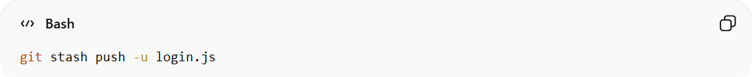
git stash push -u login.js
Only login.js will be stashed.
- Multiple Files
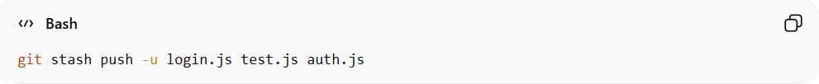
git stash push -u login.js test.js auth.js
Only the listed files (login.js, test.js, auth.js) will be stashed.

🎯 Key Difference
# Source: AI Source: Provided by: [Data Path: Persons Table -> ID Column: 1, Name_En Column: Motasem Essam] -> From: [ChatGPT] on [2/19/2026]
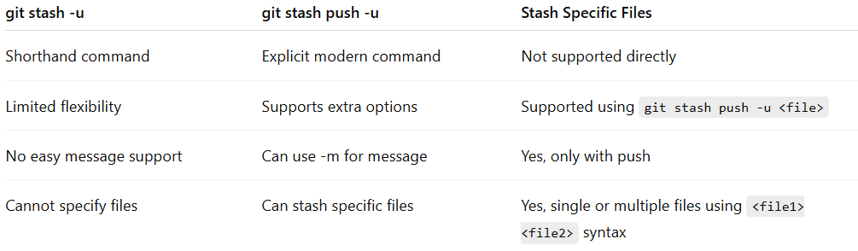
git stash -u | git stash push -u | Stash Specific Files
Shorthand command | Explicit modern command | Not supported directly
Limited flexibility | Supports extra options | Supported using git stash push -u <file>
No easy message support | Can use -m for message | Yes, only with push
Cannot specify files | Can stash specific files | Yes, single or multiple files using <file1> <file2> syntax

Stash Current Changes vs Stash Including Untracked Files
# Source: AI Source: Provided by: [Data Path: Persons Table -> ID Column: 1, Name_En Column: Motasem Essam] -> From: [ChatGPT] on [2/19/2026]
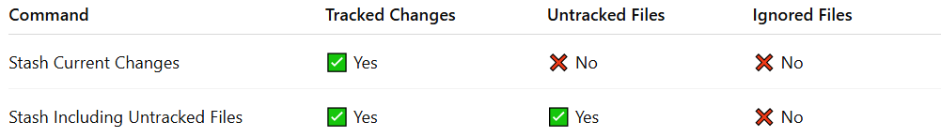
Command | Tracked Changes | Untracked Files | Ignored Files
Stash Current Changes | ✅ Yes | ❌ No | ❌ No
Stash Including Untracked Files | ✅ Yes | ✅ Yes | ❌ No

✅ 3. View Stash List
# Source: AI Source: Provided by: [Data Path: Persons Table -> ID Column: 1, Name_En Column: Motasem Essam] -> From: [ChatGPT] on [2/19/2026]
🔹 Syntax
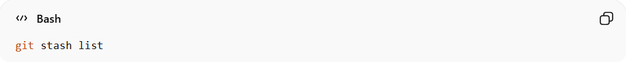
git stash list
🔹 Explanation
Displays all saved stashes in stack order (latest first).
🔹 Example
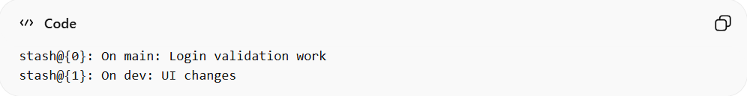
stash@{0}: On main: Login validation work
stash@{1}: On dev: UI changes

✅ 4. Apply Stash (Keep in List)

Method 1: git stash apply
# Source: AI Source: Provided by: [Data Path: Persons Table -> ID Column: 1, Name_En Column: Motasem Essam] -> From: [ChatGPT] on [2/19/2026]
🔹 Syntax
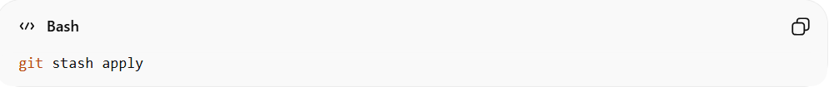
git stash apply
🔹 Explanation
- Applies the latest stash (top of the stash stack, stash@{0}).
- Keeps the stash in the list for possible reuse.
- Does not require specifying the stash index.
🔹 Example
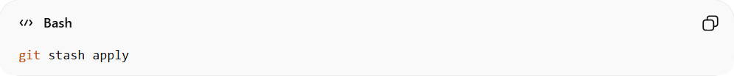
git stash apply
- If your latest stash (stash@{0}) contains changes to app.js and index.html, they will be restored to your working directory.
- The stash still exists in the list.

Method 2: git stash apply stash@{1}
# Source: AI Source: Provided by: [Data Path: Persons Table -> ID Column: 1, Name_En Column: Motasem Essam] -> From: [ChatGPT] on [2/19/2026]
🔹 Syntax
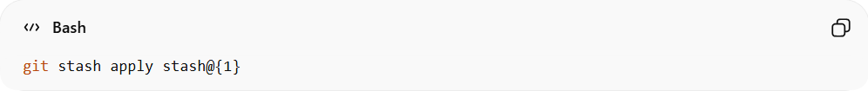
git stash apply stash@{1}
🔹 Explanation
- Applies a specific stash by index from the stash list.
- Useful when you have multiple stashes and want to restore a particular one.
- Keeps the stash in the list.
🔹 Example
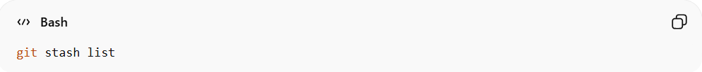
git stash list
Output:
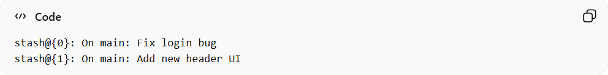
stash@{0}: On main: Fix login bug
stash@{1}: On main: Add new header UI
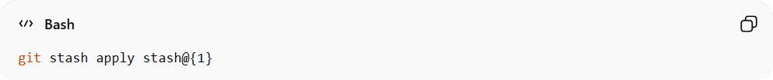
git stash apply stash@{1}
- This restores the Add new header UI changes (stash@{1}) to your working directory.
- stash@{1} still exists in the list after applying.

🎯 Key Difference
# Source: AI Source: Provided by: [Data Path: Persons Table -> ID Column: 1, Name_En Column: Motasem Essam] -> From: [ChatGPT] on [2/19/2026]
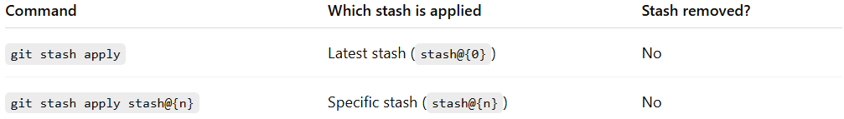
Command | Which stash is applied | Stash removed?
git stash apply | Latest stash (stash@{0}) | No
git stash apply stash@{n} | Specific stash (stash@{n}) | No

✅ 5. Pop Stash (Apply + Remove)
# Source: AI Source: Provided by: [Data Path: Persons Table -> ID Column: 1, Name_En Column: Motasem Essam] -> From: [ChatGPT] on [2/19/2026]
🔹 Syntax
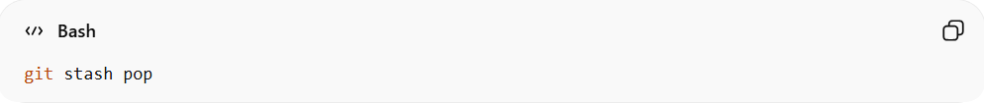
git stash pop
🔹 Explanation
Applies the latest stash and removes it from the stash list.
🔹 Example
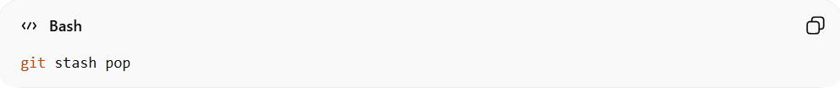
git stash pop

✅ 6. Show Stash Details

🔹 Method 1: Show Summary of Latest Stash
# Source: AI Source: Provided by: [Data Path: Persons Table -> ID Column: 1, Name_En Column: Motasem Essam] -> From: [ChatGPT] on [2/19/2026]
Syntax
git stash show
Explanation
- Shows a summary of files changed.
- Displays file names and change statistics.
- Does NOT show the exact line-by-line changes.
- Applies to the latest stash (stash@{0}).
Example
git stash show

🔹 Method 2: Show Summary of a Specific Stash
# Source: AI Source: Provided by: [Data Path: Persons Table -> ID Column: 1, Name_En Column: Motasem Essam] -> From: [ChatGPT] on [2/19/2026]
Syntax
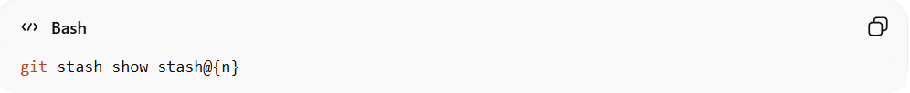
git stash show stash@{n}
Explanation
- Shows a summary of a specific stash.
- Replace n with the stash number (e.g., stash@{1}).
- Displays file names and change counts only.
Example
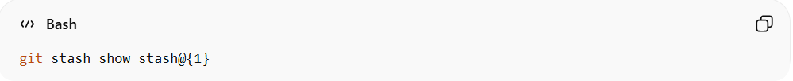
git stash show stash@{1}

🔹 Method 3: Show Full Diff of Latest Stash
# Source: AI Source: Provided by: [Data Path: Persons Table -> ID Column: 1, Name_En Column: Motasem Essam] -> From: [ChatGPT] on [2/19/2026]
Syntax
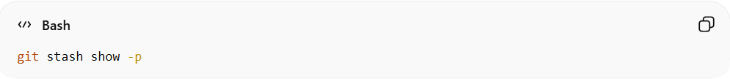
git stash show -p
Explanation
- -p stands for patch.
- Shows the complete diff (exact code changes).
- Displays added, removed, and modified lines.
- Applies to the latest stash.
Example

git stash show -p

🔹 Method 4: Show Full Diff of a Specific Stash
# Source: AI Source: Provided by: [Data Path: Persons Table -> ID Column: 1, Name_En Column: Motasem Essam] -> From: [ChatGPT] on [2/19/2026]
Syntax
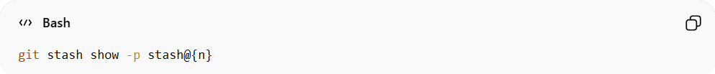
git stash show -p stash@{n}
Explanation
- Shows the complete diff of a specific stash.
- Replace n with the stash number.
- Useful for inspecting exact changes before applying or popping.
Example
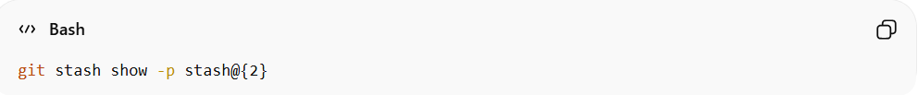
git stash show -p stash@{2}

🔎 Quick Summary Table
# Source: AI Source: Provided by: [Data Path: Persons Table -> ID Column: 1, Name_En Column: Motasem Essam] -> From: [ChatGPT] on [2/19/2026]
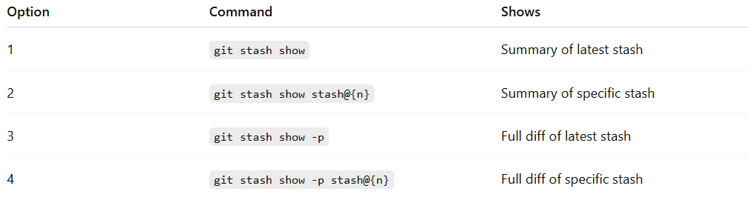
Option | Command | Shows
1 | git stash show | Summary of latest stash
2 | git stash show stash@{n} | Summary of specific stash
3 | git stash show -p | Full diff of latest stash
4 | git stash show -p stash@{n} | Full diff of specific stash

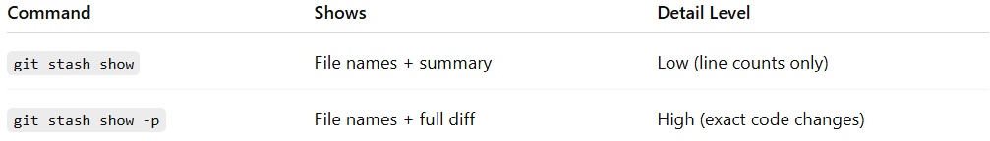
Command | Shows | Detail Level
git stash show | File names + summary | Low (line counts only)
git stash show -p | File names + full diff | High (exact code changes)

✅ 7. Drop (Delete) Specific Stash
# Source: AI Source: Provided by: [Data Path: Persons Table -> ID Column: 1, Name_En Column: Motasem Essam] -> From: [ChatGPT] on [2/19/2026]
🔹 Syntax
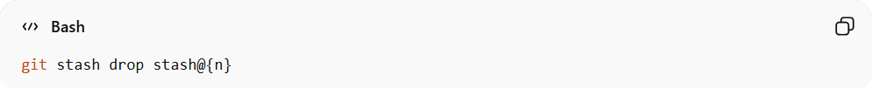
git stash drop stash@{n}
🔹 Explanation
Deletes a specific stash.
🔹 Example
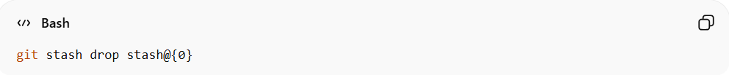
git stash drop stash@{0}

✅ 8. Clear All Stashes
# Source: AI Source: Provided by: [Data Path: Persons Table -> ID Column: 1, Name_En Column: Motasem Essam] -> From: [ChatGPT] on [2/19/2026]
🔹 Syntax
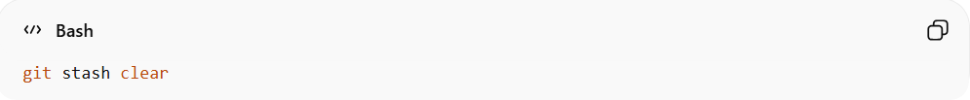
git stash clear
🔹 Explanation
Removes all stashes permanently.
🔹 Example
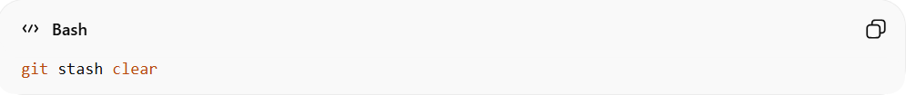
git stash clear

✅ 9. Create Branch from Stash
# Source: AI Source: Provided by: [Data Path: Persons Table -> ID Column: 1, Name_En Column: Motasem Essam] -> From: [ChatGPT] on [2/19/2026]
🔹 Syntax
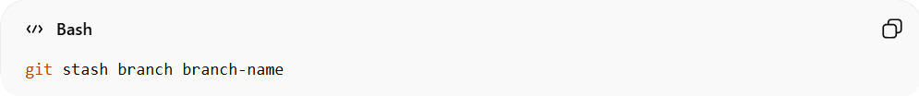
git stash branch branch-name
🔹 Explanation
Creates a new branch, applies the stash, and removes it from stash list.
🔹 Example
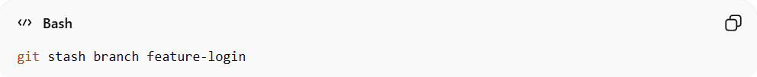
git stash branch feature-login

🎯 Quick Summary Table
# Source: AI Source: Provided by: [Data Path: Persons Table -> ID Column: 1, Name_En Column: Motasem Essam] -> From: [ChatGPT] on [2/19/2026]
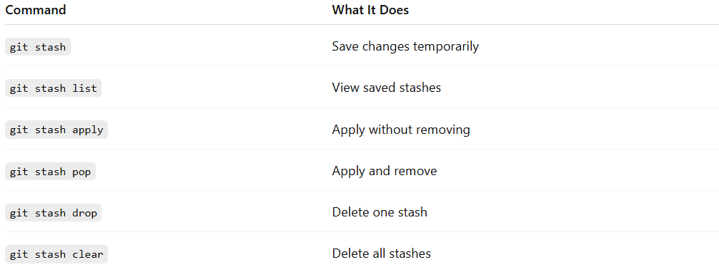
Command | What It Does
git stash | Save changes temporarily
git stash list | View saved stashes
git stash apply | Apply without removing
git stash pop | Apply and remove
git stash drop | Delete one stash
git stash clear | Delete all stashes

Example

✅ 1. Stash Current Changes

Method 1: git stash
# Source: ScreenShots Source: Provided by: [Persons Table -> ID Column: 1, Name_En Column: Motasem Essam] -> Tool: [Lightshot Program] -> From [Operating System: Windows] on [2/19/2026]
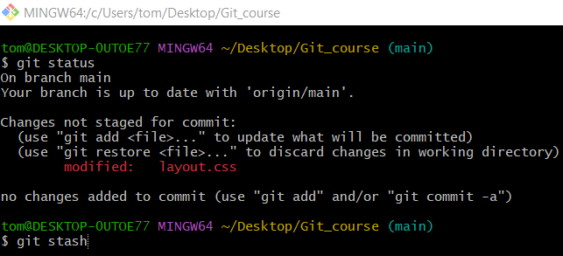
git stash
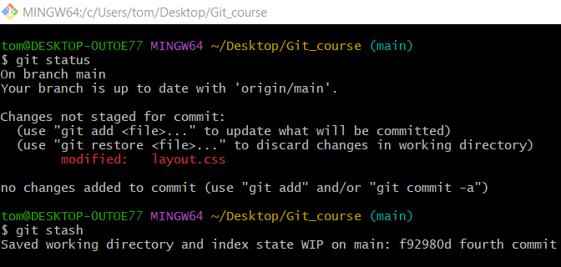
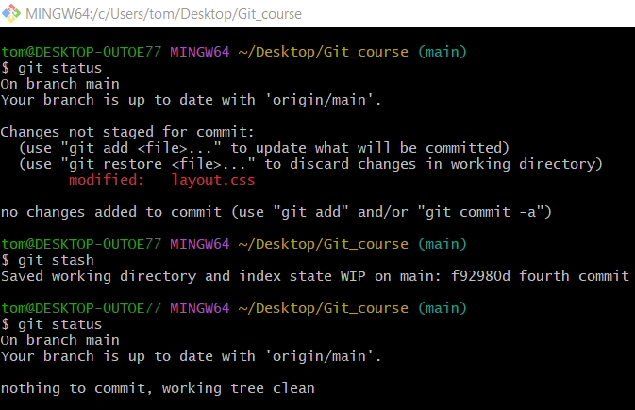

Method 2: git stash push
# Source: ScreenShots Source: Provided by: [Persons Table -> ID Column: 1, Name_En Column: Motasem Essam] -> Tool: [Lightshot Program] -> From [Operating System: Windows] on [2/19/2026]
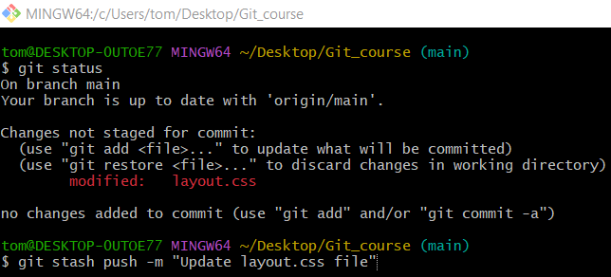
git stash push -m "Update layout.css file"
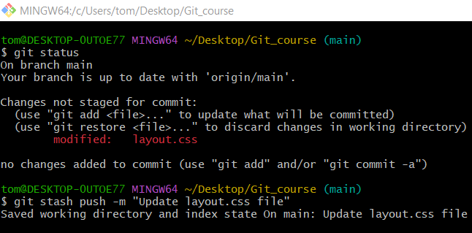
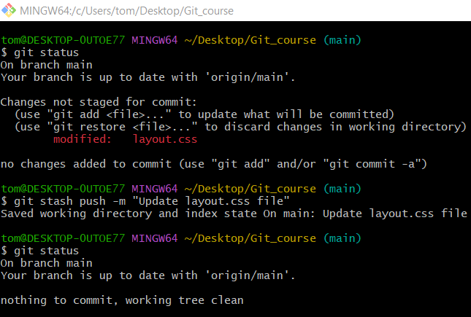

Method 3: Stash Specific Files
# Source: ScreenShots Source: Provided by: [Persons Table -> ID Column: 1, Name_En Column: Motasem Essam] -> Tool: [Lightshot Program] -> From [Operating System: Windows] on [2/19/2026]
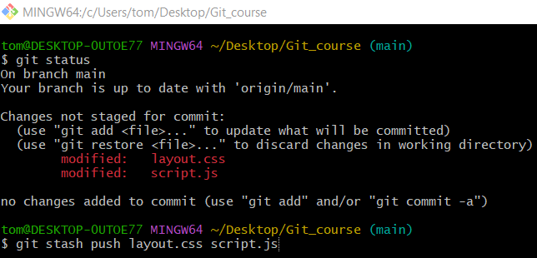
git stash push layout.css script.js
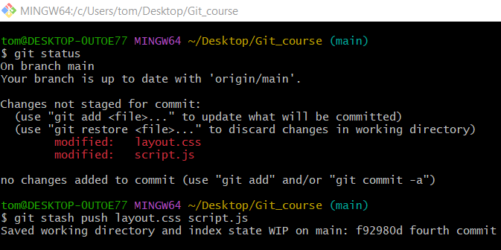
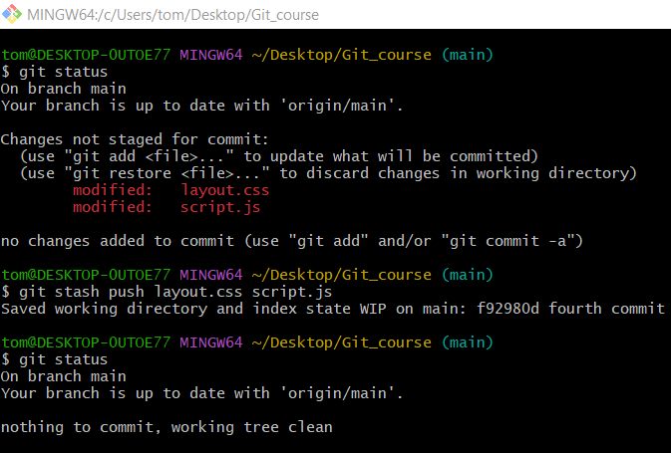

✅ 2. Stash Including Untracked Files

Method 1: git stash -u
# Source: ScreenShots Source: Provided by: [Persons Table -> ID Column: 1, Name_En Column: Motasem Essam] -> Tool: [Lightshot Program] -> From [Operating System: Windows] on [2/19/2026]
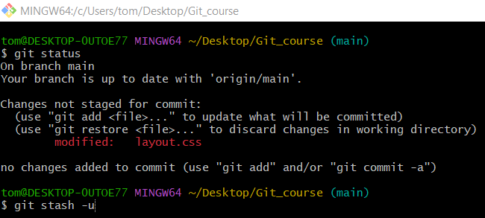
git stash -u
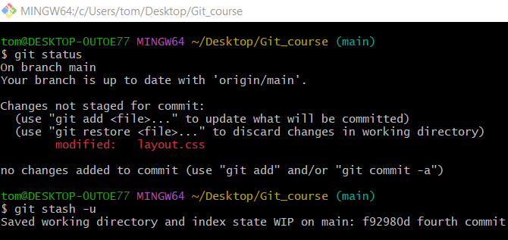
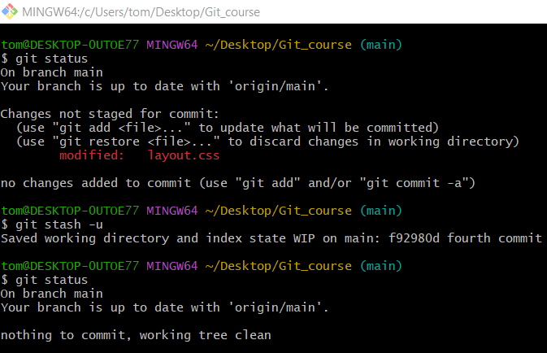

Method 2: git stash push -u
# Source: ScreenShots Source: Provided by: [Persons Table -> ID Column: 1, Name_En Column: Motasem Essam] -> Tool: [Lightshot Program] -> From [Operating System: Windows] on [2/19/2026]
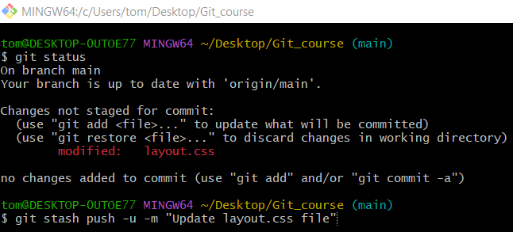
git stash push -u -m "Update layout.css file"
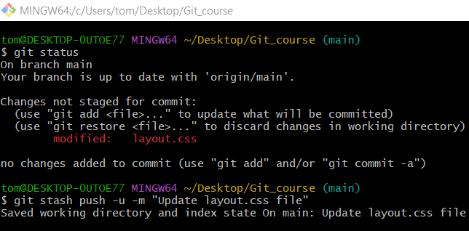
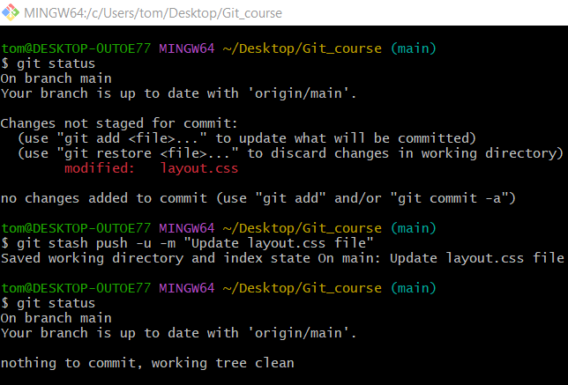

Method 3: Stash Specific Files Including Untracked
# Source: ScreenShots Source: Provided by: [Persons Table -> ID Column: 1, Name_En Column: Motasem Essam] -> Tool: [Lightshot Program] -> From [Operating System: Windows] on [2/19/2026]
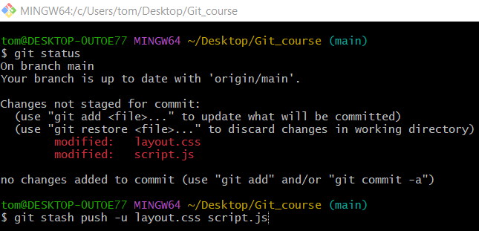
git stash push -u layout.css script.js
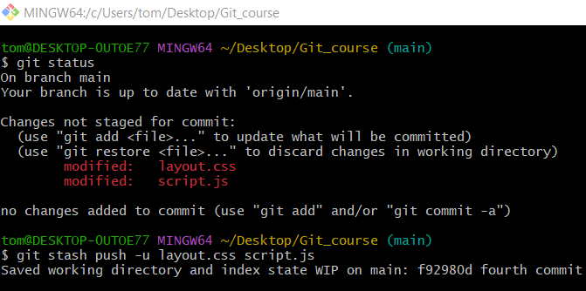
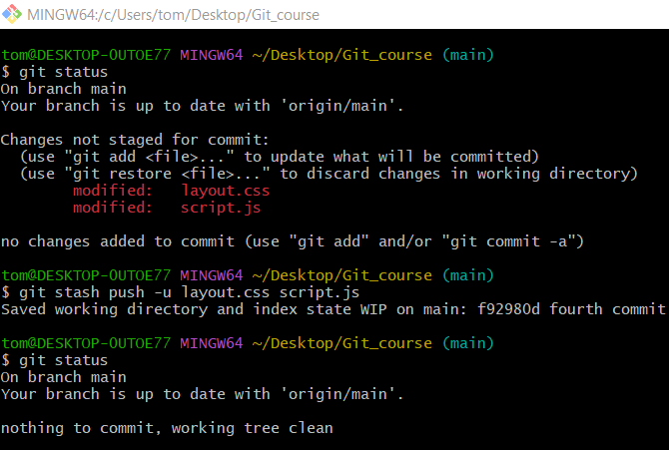

✅ 3. View Stash List
# Source: ScreenShots Source: Provided by: [Persons Table -> ID Column: 1, Name_En Column: Motasem Essam] -> Tool: [Lightshot Program] -> From [Operating System: Windows] on [2/19/2026]
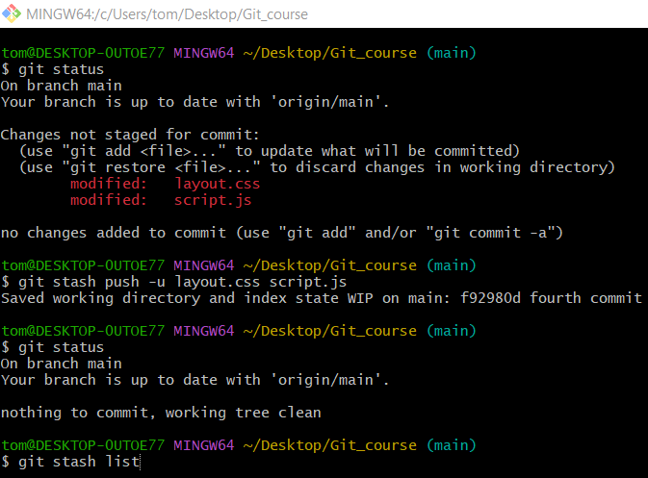
git stash list
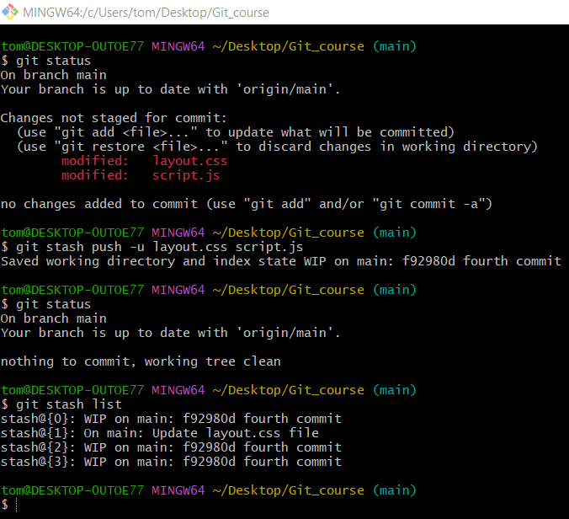

✅ 4. Apply Stash (Keep in List)

Method 1: git stash apply
# Source: ScreenShots Source: Provided by: [Persons Table -> ID Column: 1, Name_En Column: Motasem Essam] -> Tool: [Lightshot Program] -> From [Operating System: Windows] on [2/19/2026]
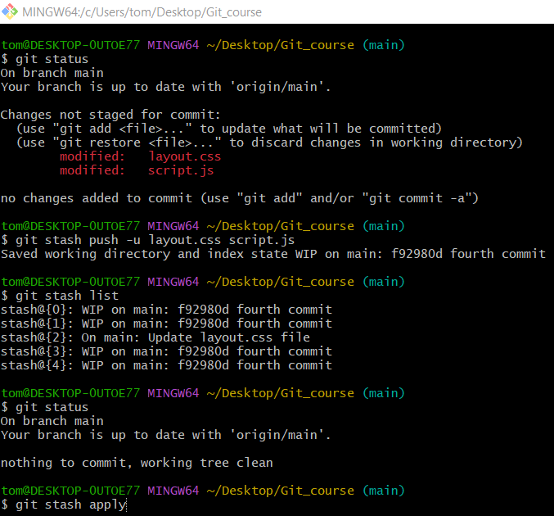
git stash apply
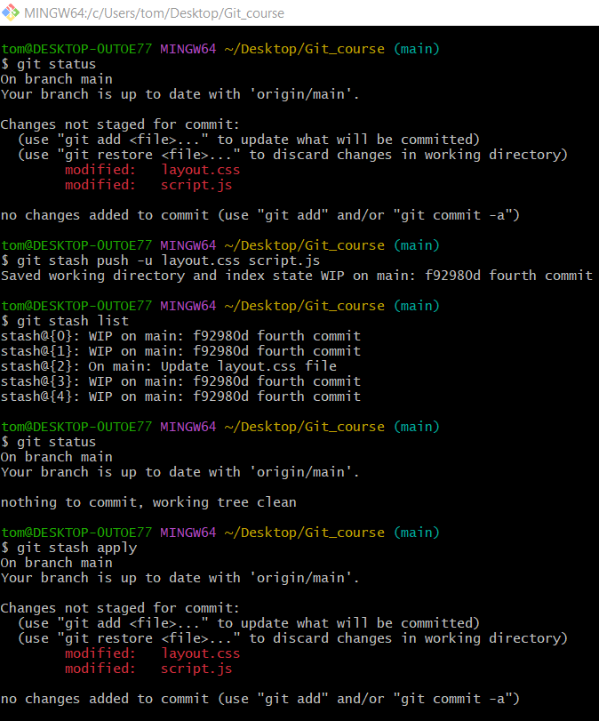
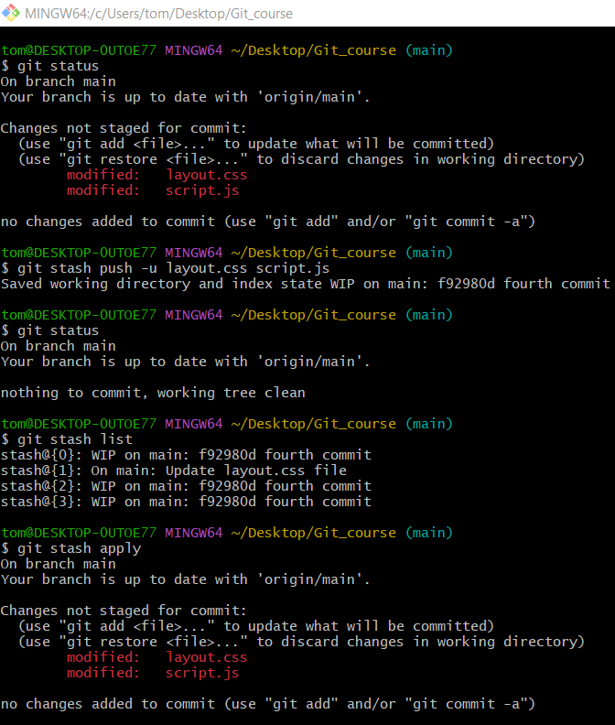
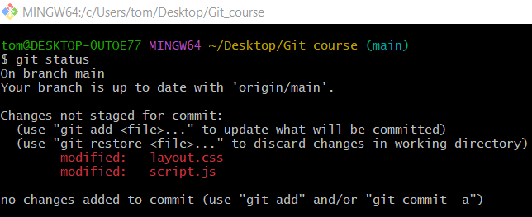

Method 2: git stash apply stash@{1}
# Source: ScreenShots Source: Provided by: [Persons Table -> ID Column: 1, Name_En Column: Motasem Essam] -> Tool: [Lightshot Program] -> From [Operating System: Windows] on [2/19/2026]
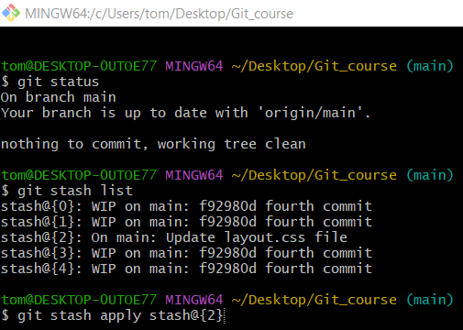
git stash apply stash@{2}
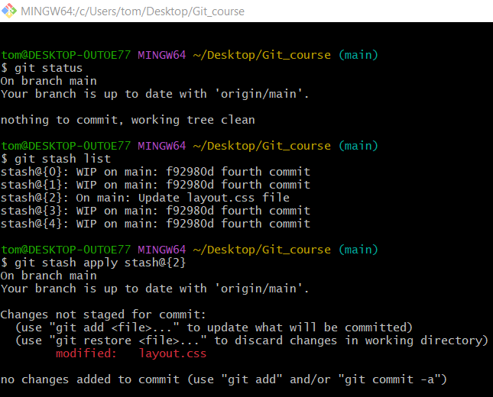

✅ 5. Pop Stash (Apply + Remove)
# Source: ScreenShots Source: Provided by: [Persons Table -> ID Column: 1, Name_En Column: Motasem Essam] -> Tool: [Lightshot Program] -> From [Operating System: Windows] on [2/19/2026]
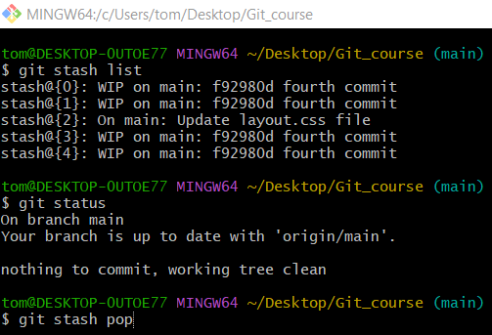
git stash pop
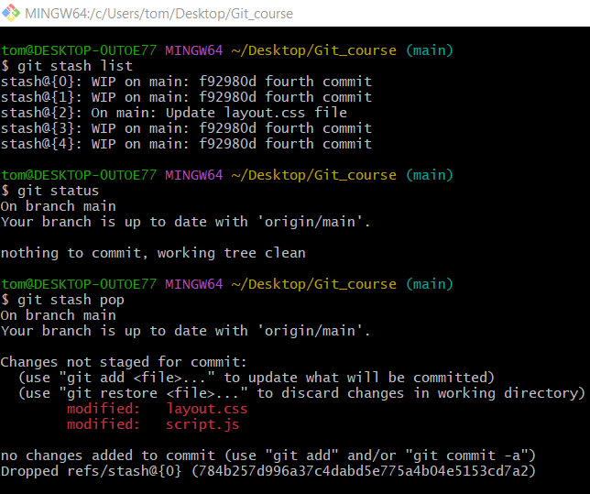
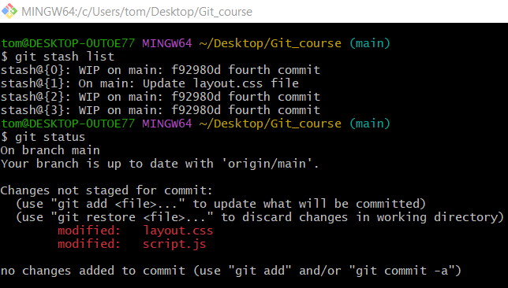

✅ 6. Show Stash Details

🔹 Method 1: git stash show
# Source: ScreenShots Source: Provided by: [Persons Table -> ID Column: 1, Name_En Column: Motasem Essam] -> Tool: [Lightshot Program] -> From [Operating System: Windows] on [2/19/2026]
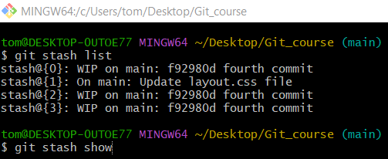
git stash show
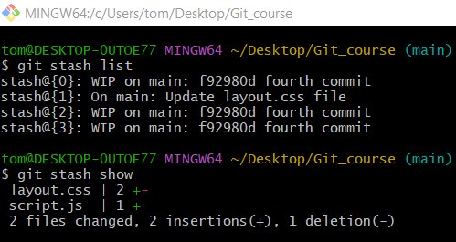

🔹 Method 2: Show Summary of a Specific Stash
# Source: ScreenShots Source: Provided by: [Persons Table -> ID Column: 1, Name_En Column: Motasem Essam] -> Tool: [Lightshot Program] -> From [Operating System: Windows] on [2/19/2026]
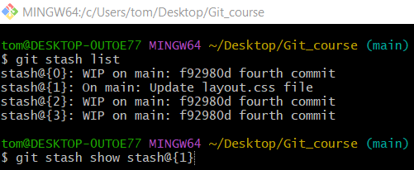
git stash show stash@{1}
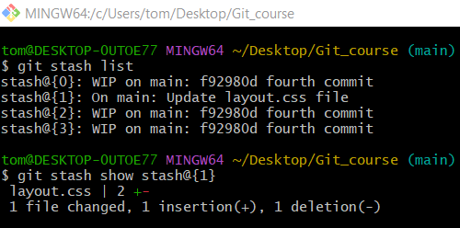

🔹 Method 3: Show Full Diff of Latest Stash
# Source: ScreenShots Source: Provided by: [Persons Table -> ID Column: 1, Name_En Column: Motasem Essam] -> Tool: [Lightshot Program] -> From [Operating System: Windows] on [2/19/2026]
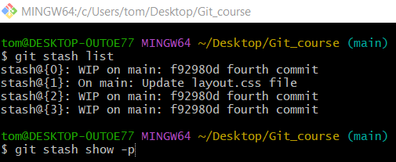
git stash show -p
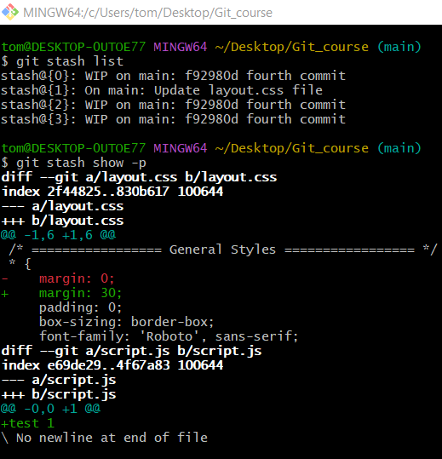

🔹 Method 4: Show Full Diff of a Specific Stash
# Source: ScreenShots Source: Provided by: [Persons Table -> ID Column: 1, Name_En Column: Motasem Essam] -> Tool: [Lightshot Program] -> From [Operating System: Windows] on [2/19/2026]
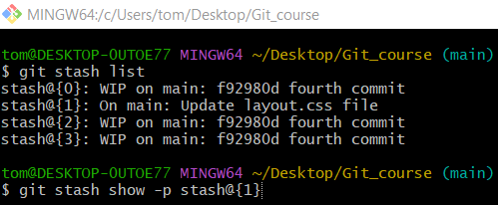
git stash show -p stash@{1}
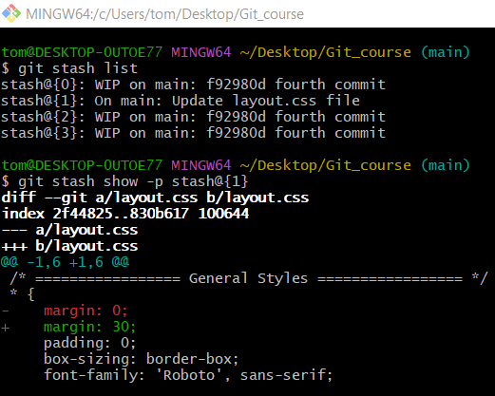

✅ 7. Drop (Delete) Specific Stash
# Source: ScreenShots Source: Provided by: [Persons Table -> ID Column: 1, Name_En Column: Motasem Essam] -> Tool: [Lightshot Program] -> From [Operating System: Windows] on [2/19/2026]
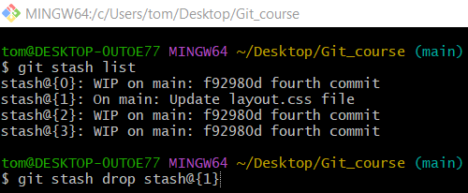
git stash drop stash@{1}
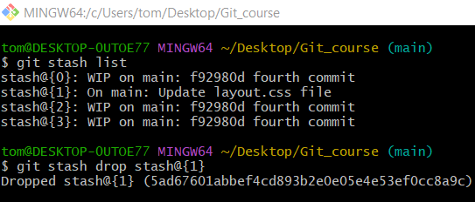
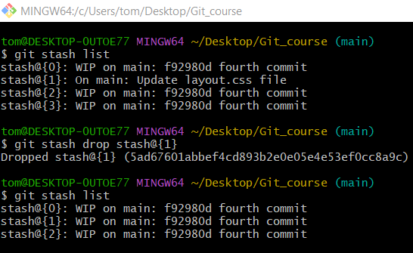

✅ 8. Clear All Stashes
# Source: AI Source: Provided by: [Data Path: Persons Table -> ID Column: 1, Name_En Column: Motasem Essam] -> From: [ChatGPT] on [2/19/2026]
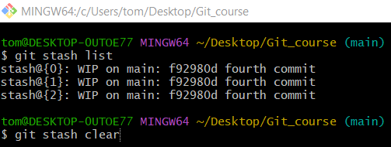
git stash clear
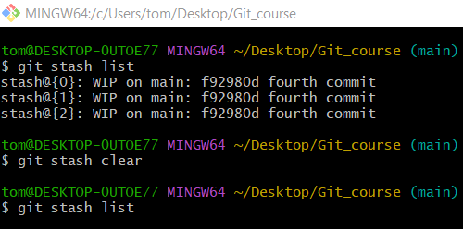

✅ 9. Create Branch from Stash
# Source: ScreenShots Source: Provided by: [Persons Table -> ID Column: 1, Name_En Column: Motasem Essam] -> Tool: [Lightshot Program] -> From [Operating System: Windows] on [2/19/2026]
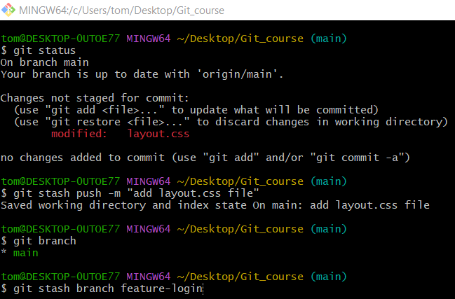
git stash branch feature-login
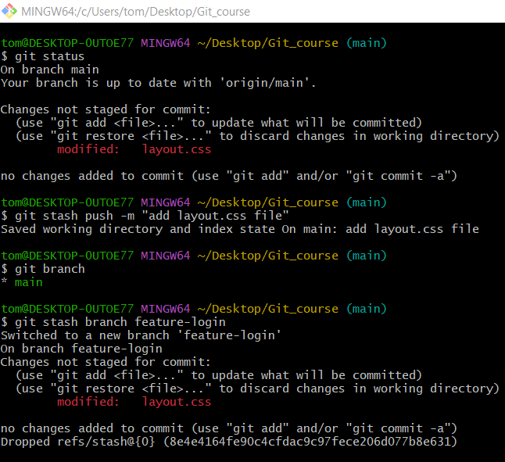
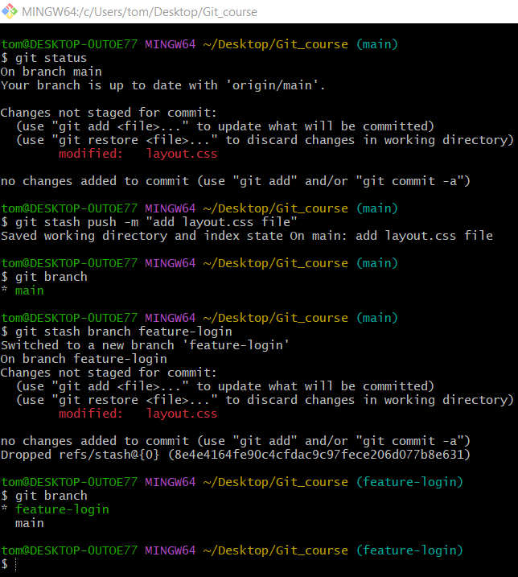

But if you switch to main
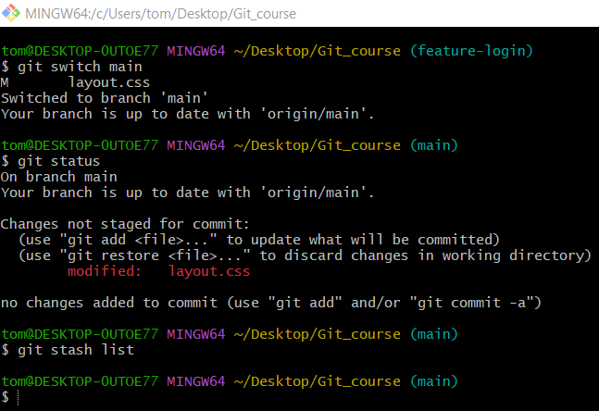

🎯 When to Use Stash
# Source: AI Source: Provided by: [Data Path: Persons Table -> ID Column: 1, Name_En Column: Motasem Essam] -> From: [ChatGPT] on [2/19/2026]
- You need to quickly switch branches
- You’re not ready to commit
- You want to pull latest changes but have local edits

🧠 Summary
# Source: AI Source: Provided by: [Data Path: Persons Table -> ID Column: 1, Name_En Column: Motasem Essam] -> From: [ChatGPT] on [2/19/2026]
Git stash temporarily saves uncommitted changes so you can work on something else and reapply them later.

